**Contents**

**Project Creation** 3

**Configuring Project Properties** 4

Adding OpenCV to the Project 4

**Linking the .cpp and .h files** 6

**Toolbox Main Functions** 6

**Main Tab** 11

**Buttons Explanation** 12

1-Select image 12

2-image Details 12

3-Convert Gray Scale 13

5-Save 14

**Edit Tab** 14

1-Adjust Position (image translation) 15

2-Mirror (flipping) 15

3-Rotate 16

4-Skewing 16

5-Zoom (Scaling) 17

6-crop 17

**Advanced Edit** 18

1-Show Graphical Representation (Histogram) 18

2-Adjust Contrast (Histogram Equalization) 19

3-Negative 19

4-Water Mark (Blinding) 20

5-Adjust Brightness (Power Transformation (Gamma Correction)) 21

6-Brighten Dark Images (Log Transformation) 21

7-Image Slicing Levels (Bit Plane Slicing) 22

8-Choose Certain Details (Thresholding) 23

9-Highlight Gray range (Gray Level Slicing) 23

**Filters** 24

1-Box Filter (Traditional Filter) 25

2-Pyramidal Blurring (Pyramidal Filter) 25

3-Remove High Noise (Circular Filter) 26

4-Cone Blurring (Cone Filter) 26

5-Fixing Extremely Dark or Bright Values (Median Filter) 27

6-Reducing high noises and blurring (Gaussian Filter) 28

7-Thick Sharpening (Sobel Filter) 28

8-Thin Sharpening (Laplacian Filter) 29

**Locate Objects and Boundaries** 30

1-Detecting Thin Edges (Laplacian Segmentation) 31

2-Detecting Certain Edges Of The Images (Thresholding Segmentation) 31

3-Detecting all Edge’s Direction (Sobel Segmentation) 32

4-Detecting the main object (DFT Low Pass Filter) 32

4-Denying the main object (DFT High Pass Filter) 33

5-Mathematical Shapes Detector (Shapes Recognition) 33

**Noise** 34

1-Salt and pepper Noise 34

2-Gaussian Noise 35

Themes 35

1-Dark Theme 35

2-Gray Theme 36

3-White Theme 36

# **Project Creation**

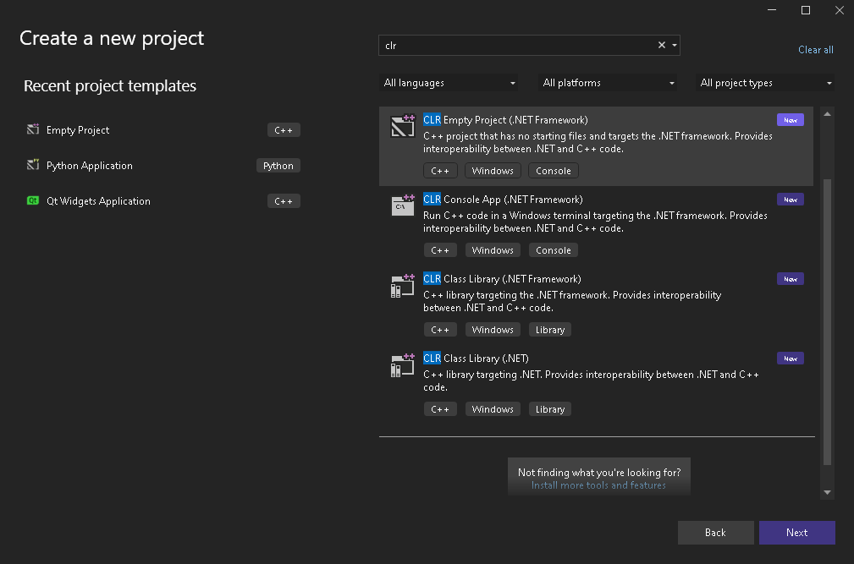

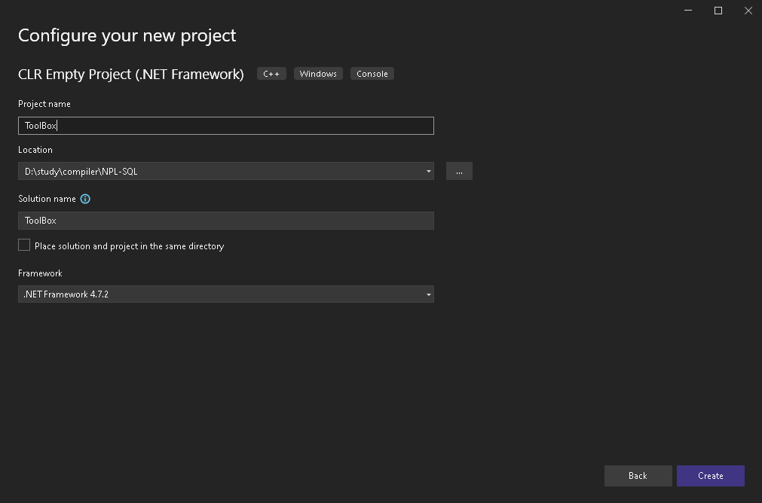

# **Configuring Project Properties**

## Adding OpenCV to the Project

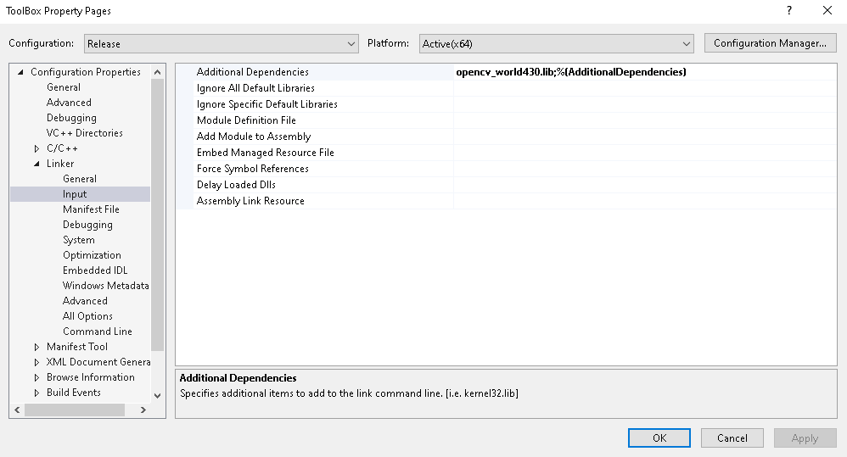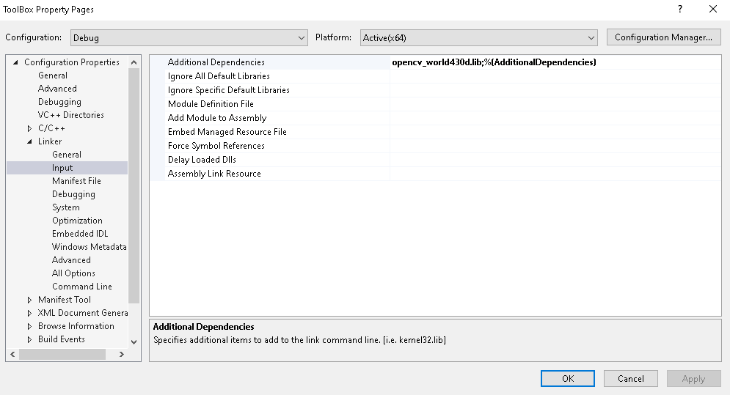

# **Linking the .cpp and .h files**

Create cpp file and import this code to it

#include "MyForm.h"

using namespace System;

using namespace System::Windows::Forms;

[STAThread]

void main(array<String^>^ args) {

Application::EnableVisualStyles();

Application::SetCompatibleTextRenderingDefault(false);

Application::Run(gcnew ToolBox::MyForm);

}

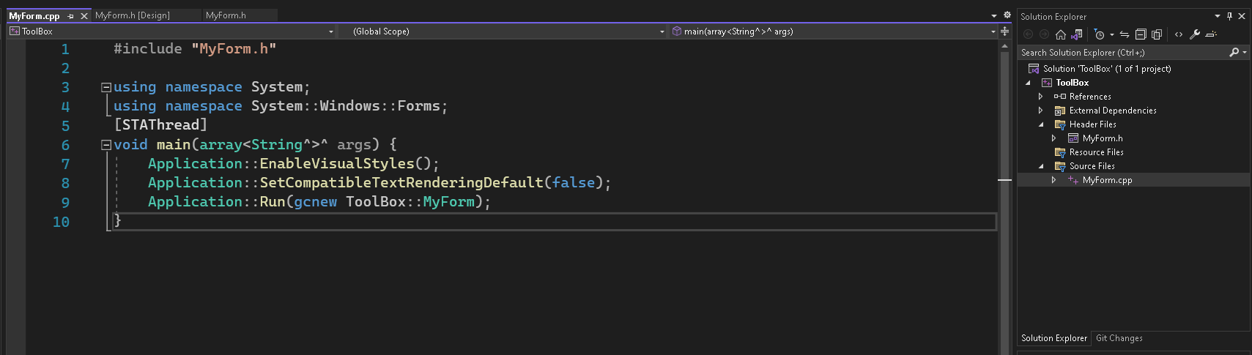

# **Toolbox Main Functions**

Now Head Towards MyForm.h File to include the used libraries

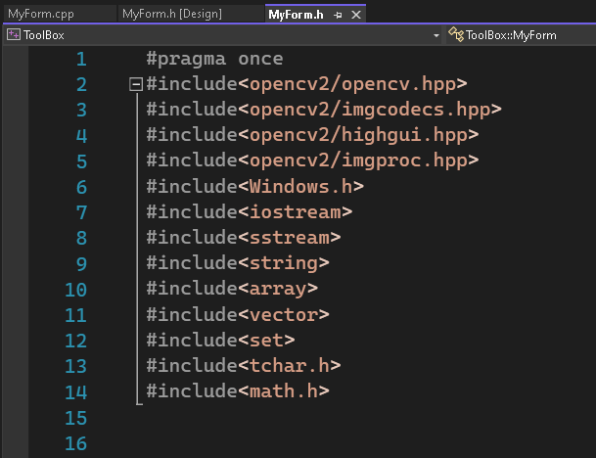

After Creating the GUI, the function of each button must be written

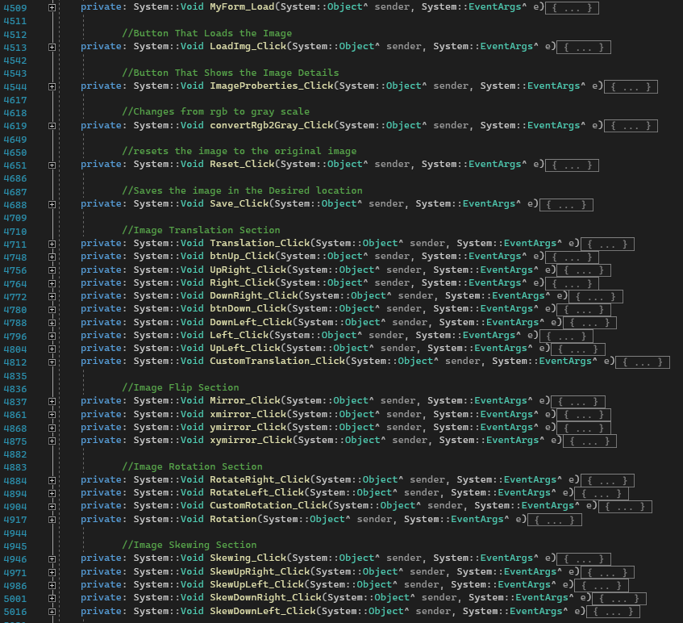

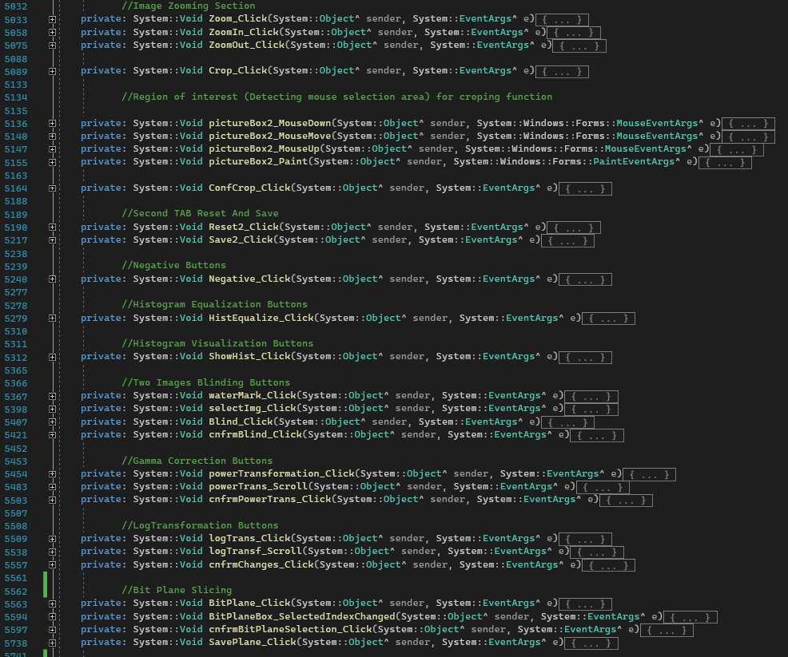

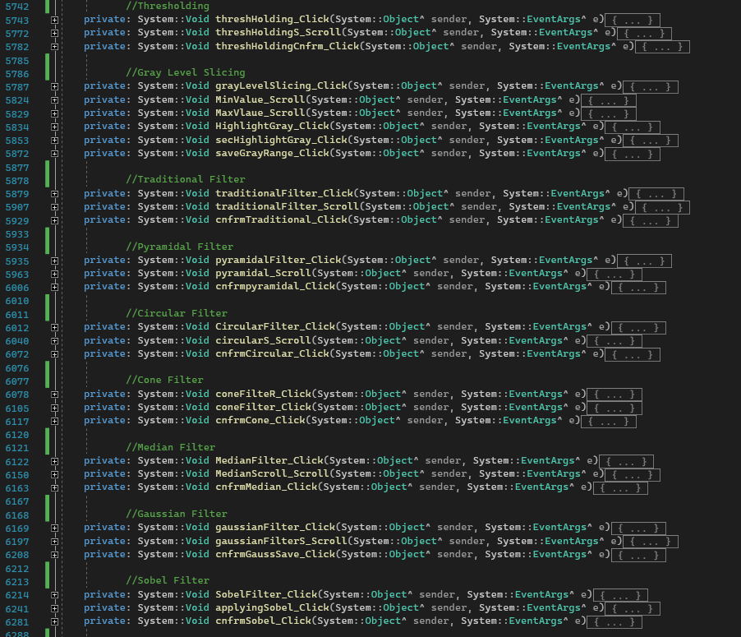

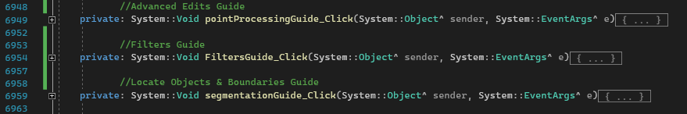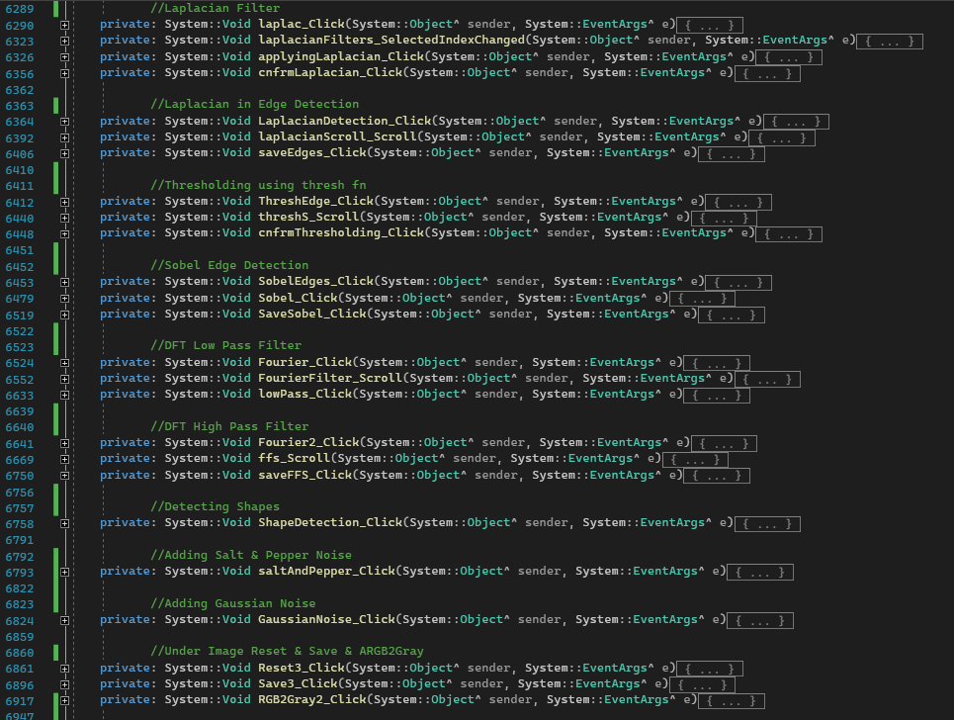

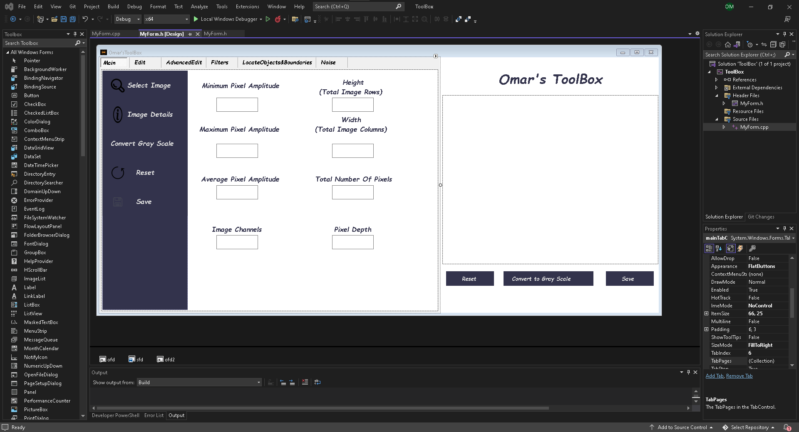To access the GUI head towards MyForm.h[Design]

Screen of the GUI after running the application this **main** screen appears

## **Main Tab**

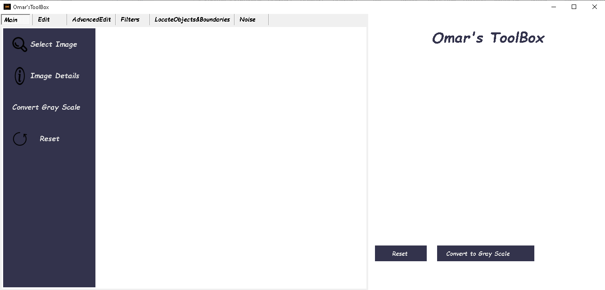

# **Buttons Explanation**

### 1-Select image

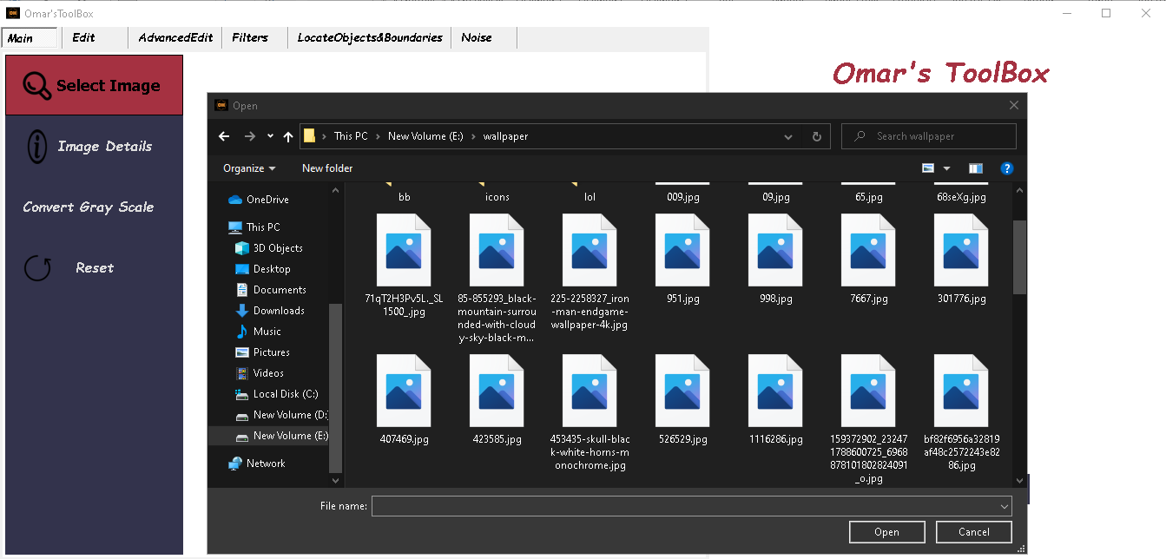 -Opens a dialog for the user to browse to get the required image.

### 2-image Details

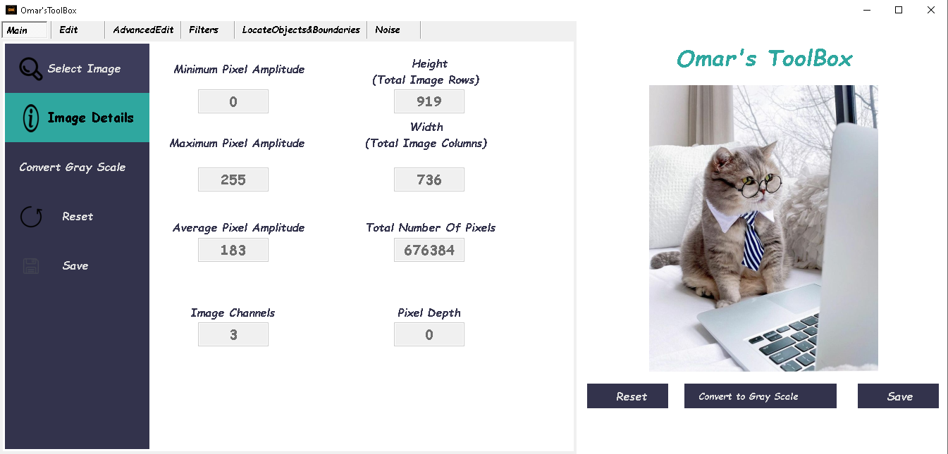 -Shows the image Properties

### 3-Convert Gray Scale

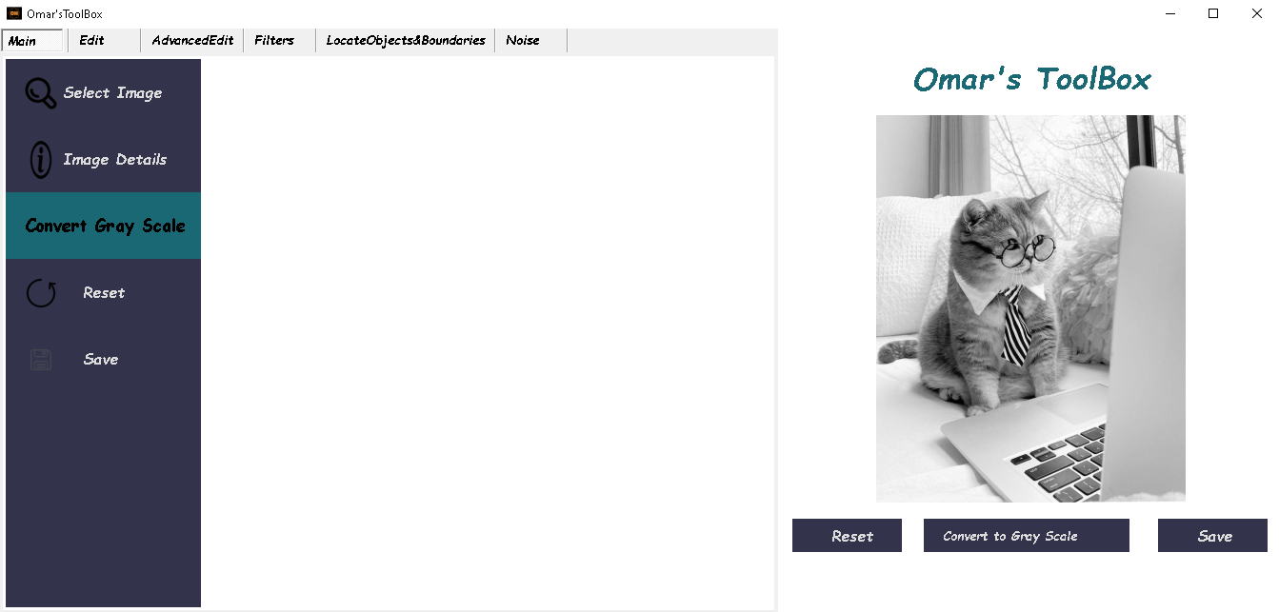 -Converts from RGB to gray Scale

4-Reset

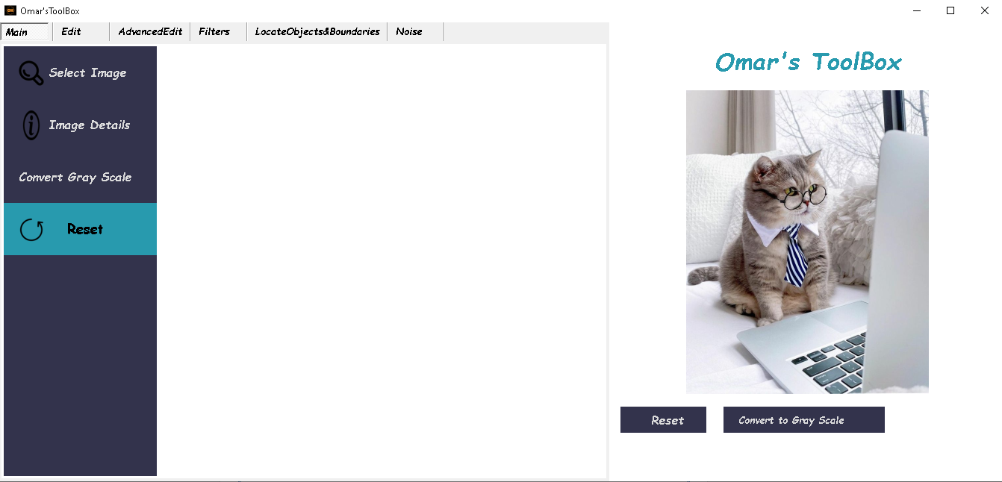 -Removes all the changes that were made to the image

### 5-Save

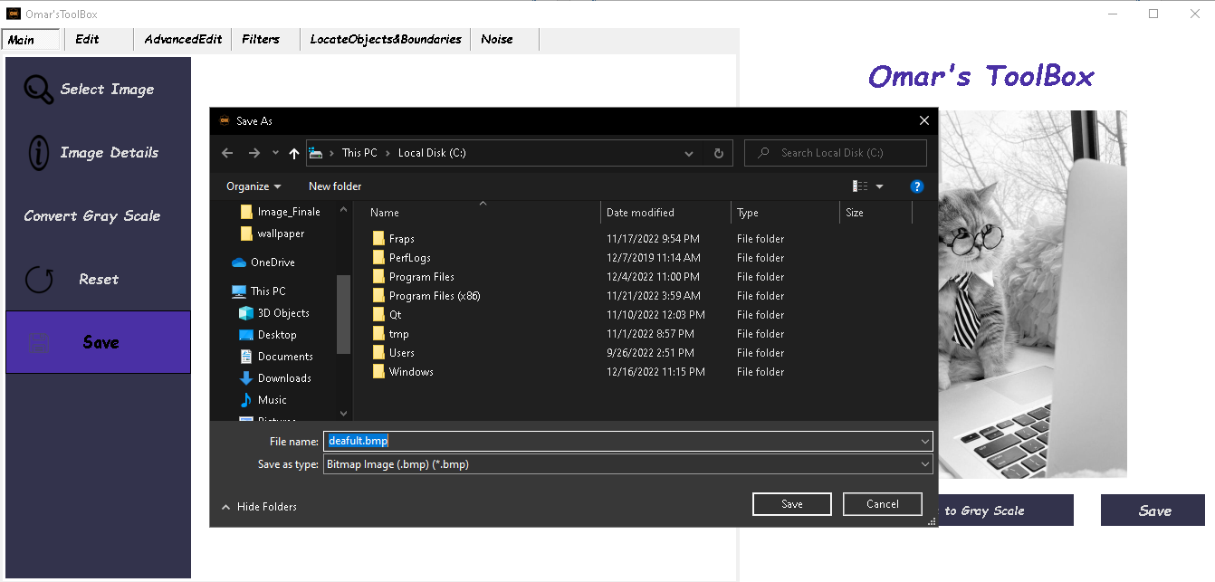 -Opens a dialog to enables the user to select the location of the saved image

The Second Tab is **Edit (**for the image transformation operations**)**

## **Edit Tab**

### 1-Adjust Position (image translation)

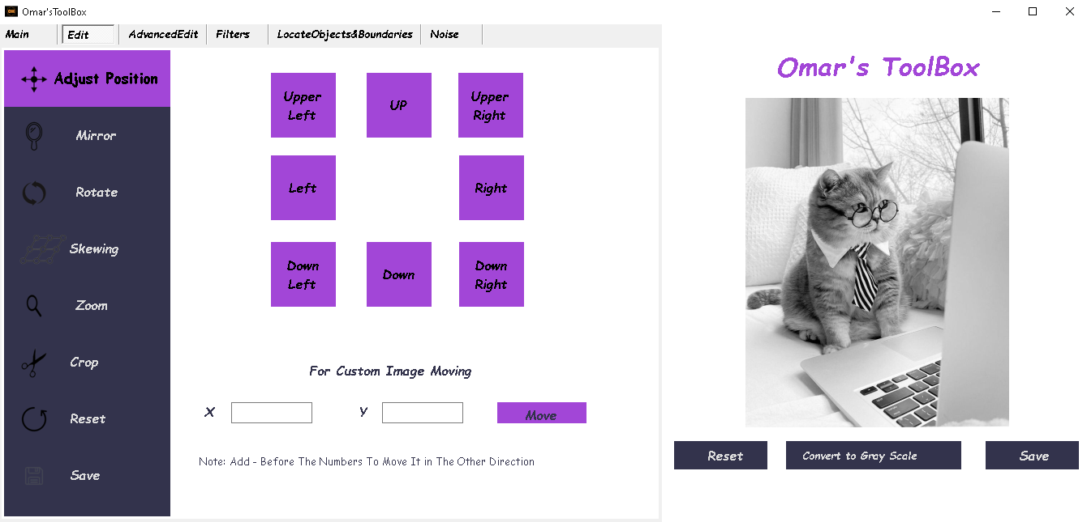 -moves the image along the x axis or the y axis

### 2-Mirror (flipping)

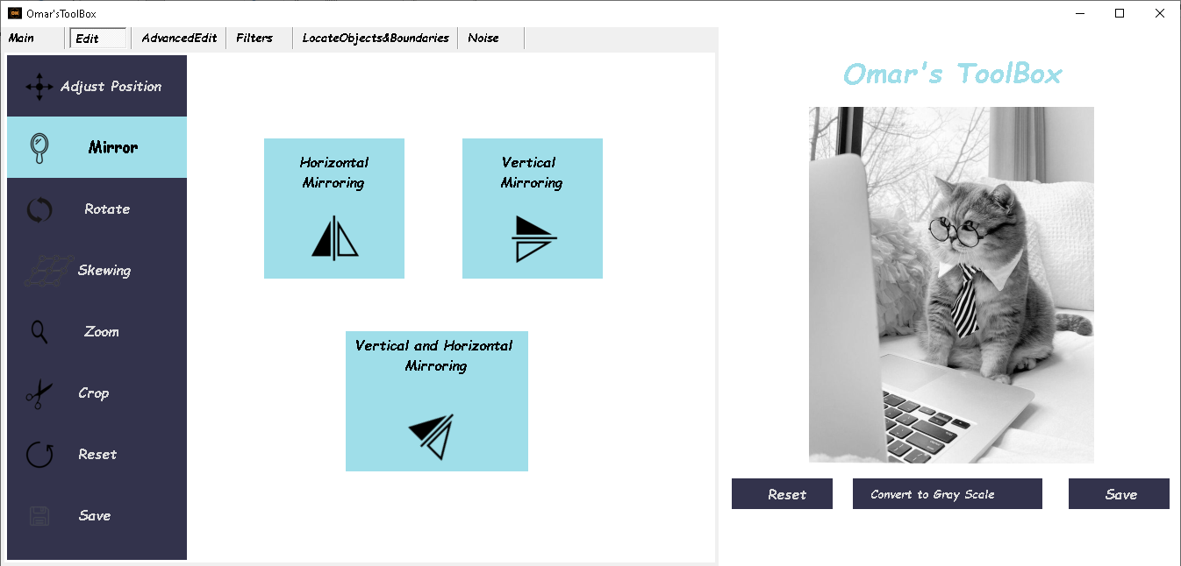 -flips the image along the x axis or y axis or both

### 3-Rotate

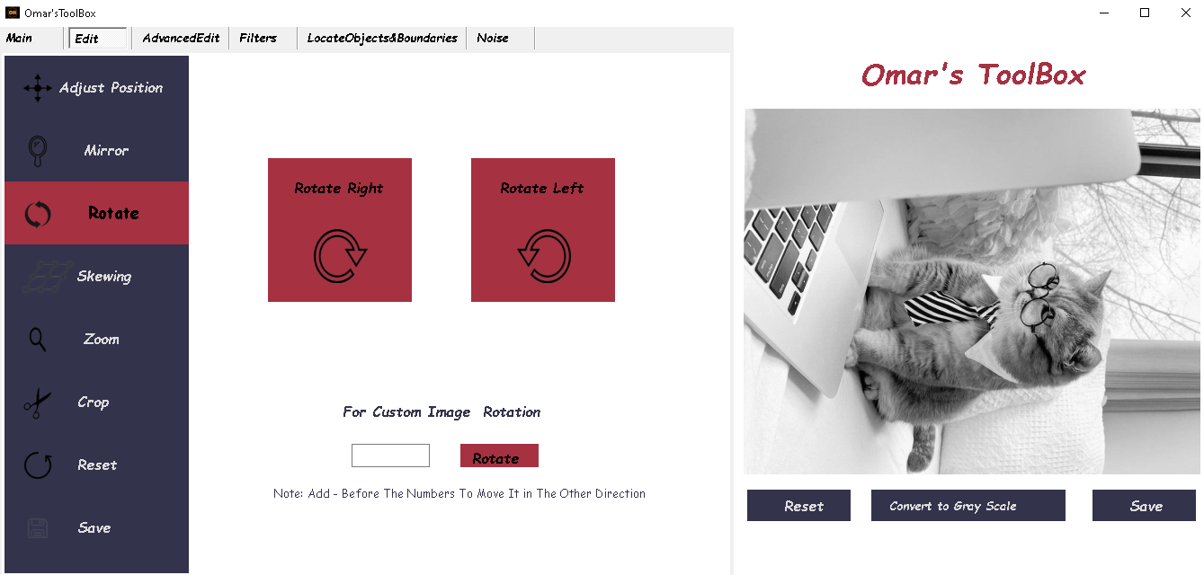 -rotates the image

### 4-Skewing

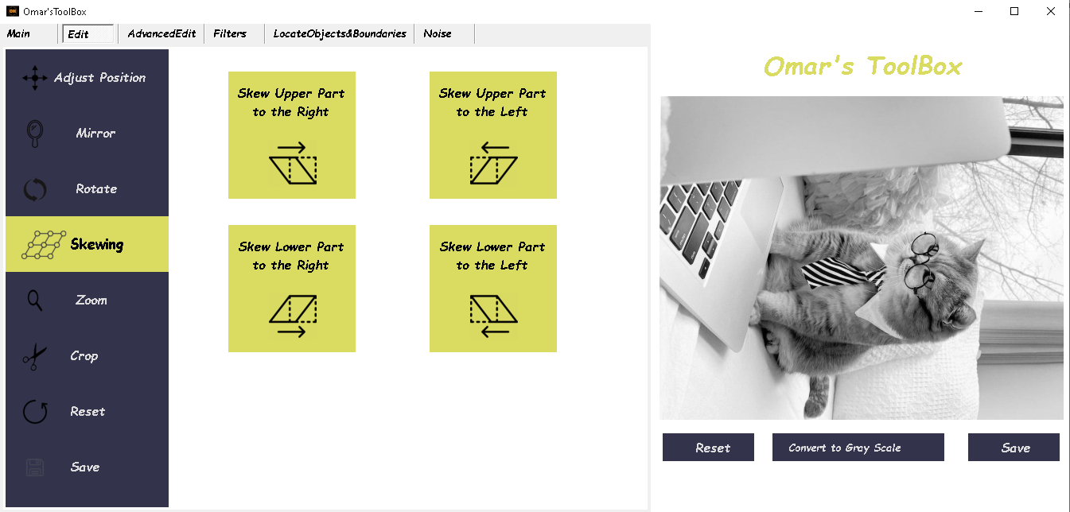 -skew the image in any direction

### 5-Zoom (Scaling)

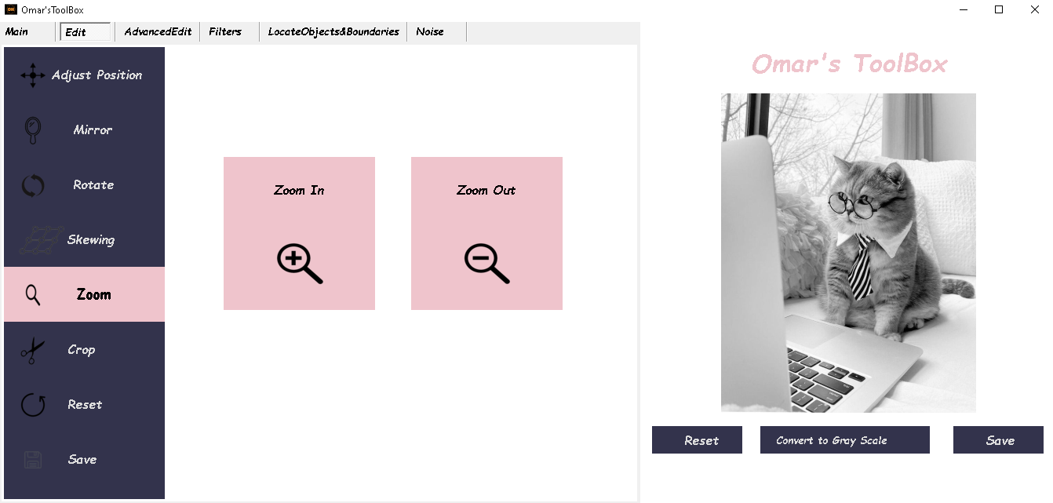 -zooming in or zooming out

### 6-crop

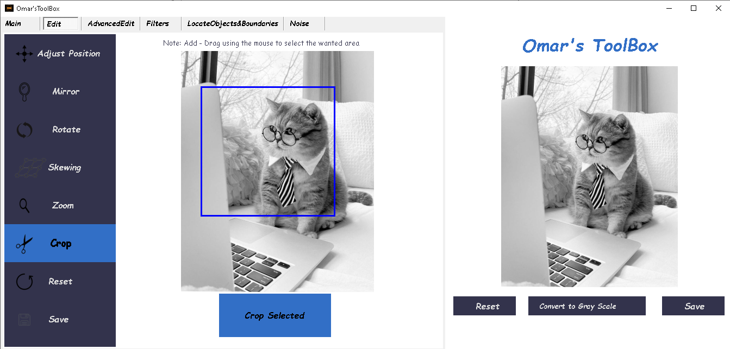 -Crops the image

The Third Tab is **Advanced Edit (**for the Point Processing operations**)**

## **Advanced Edit**

### 1-Show Graphical Representation (Histogram)

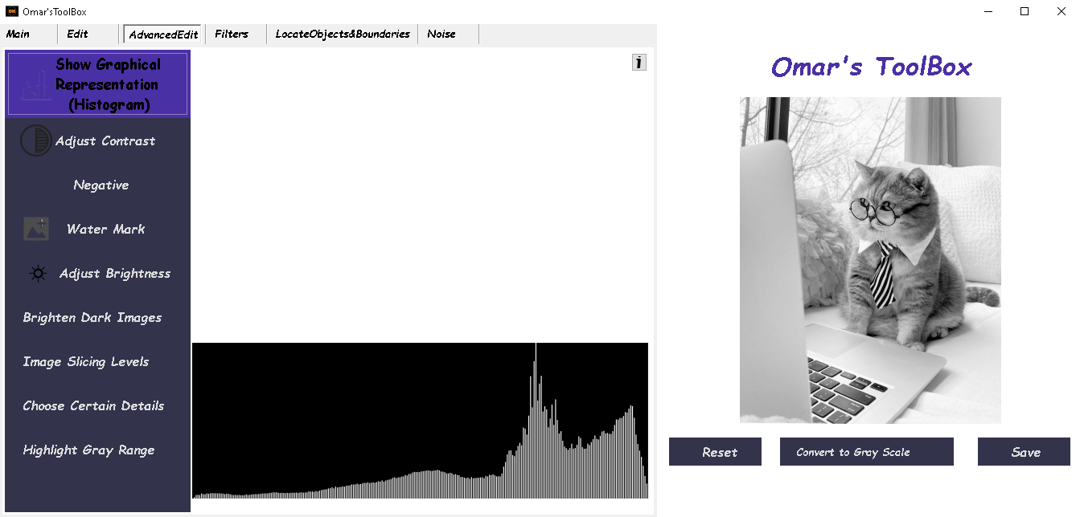 -Shows the histogram

### 2-Adjust Contrast (Histogram Equalization)

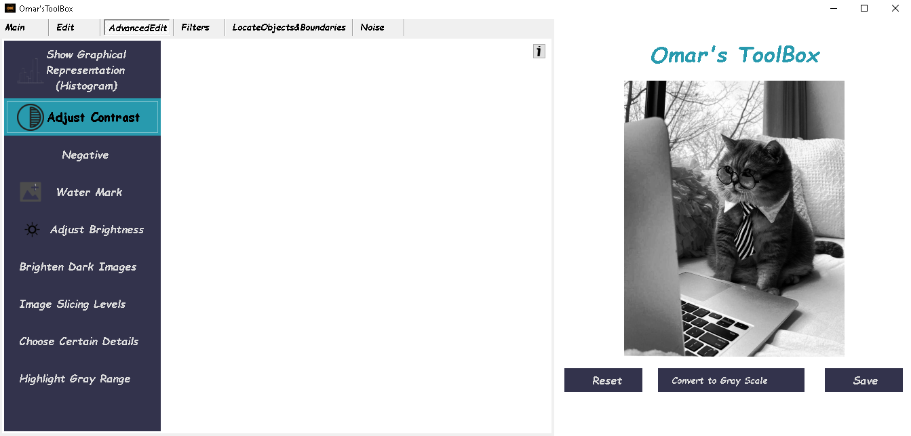 -perform contrast stretching (Histogram Equalization)

### 3-Negative

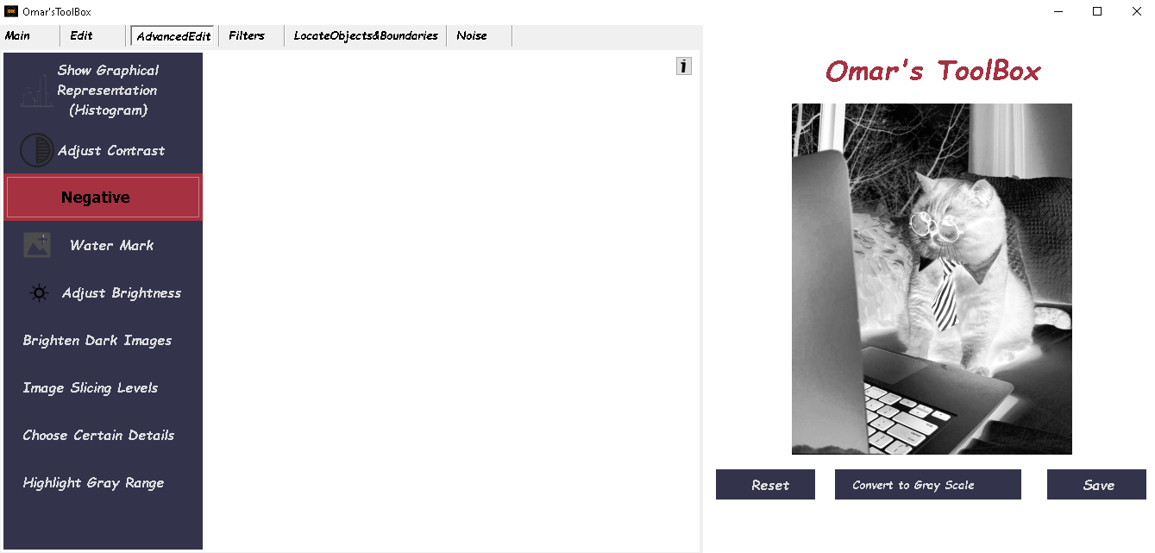 -flips all the pixels values

### 4-Water Mark (Blinding)

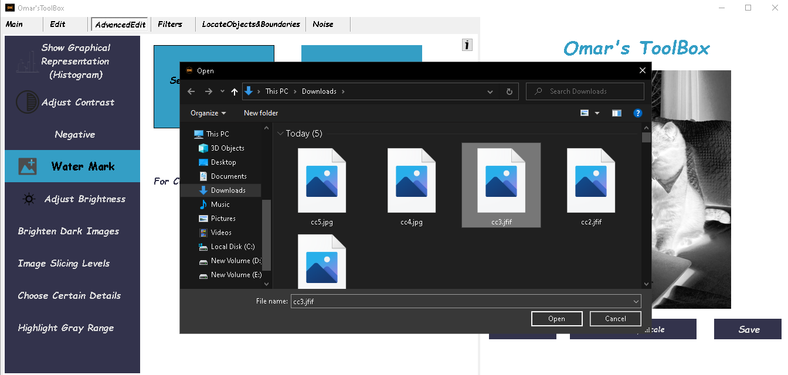 -Blinds two images together

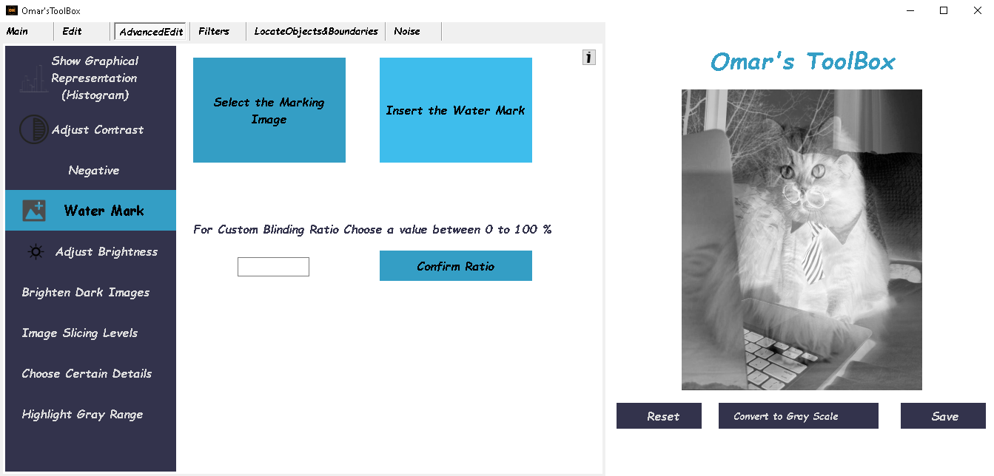

### 5-Adjust Brightness (Power Transformation (Gamma Correction))

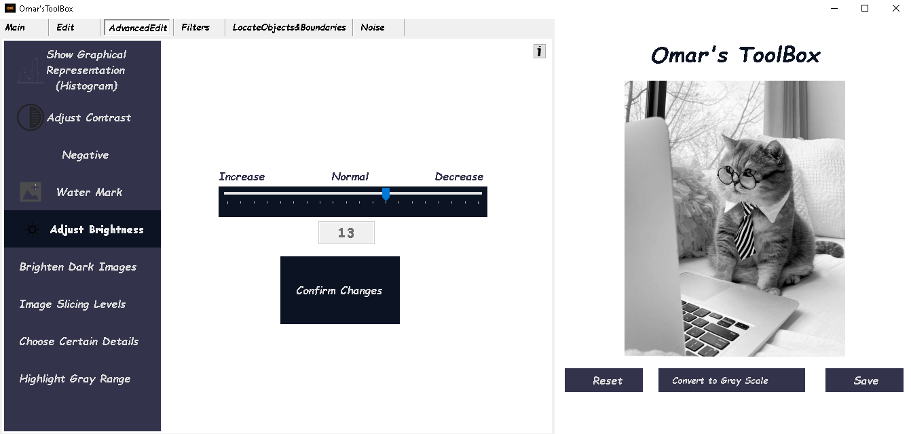 -Used to map a narrow range of dark input values into a wider range of output values or vice versa depending on γ value

### 6-Brighten Dark Images (Log Transformation)

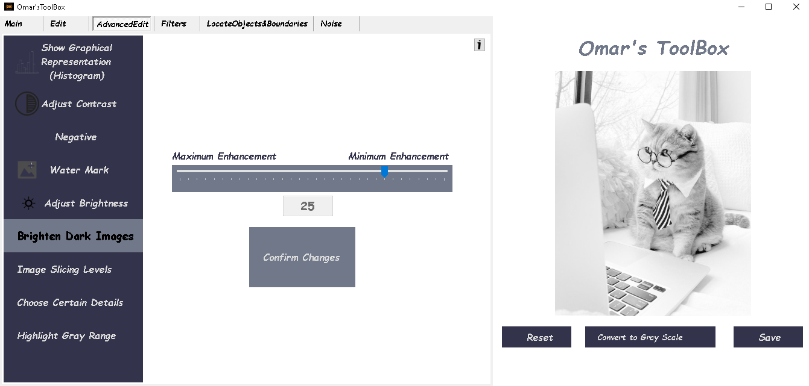 -Used to map a narrow range of dark input values into a wider range of output values

### 7-Image Slicing Levels (Bit Plane Slicing)

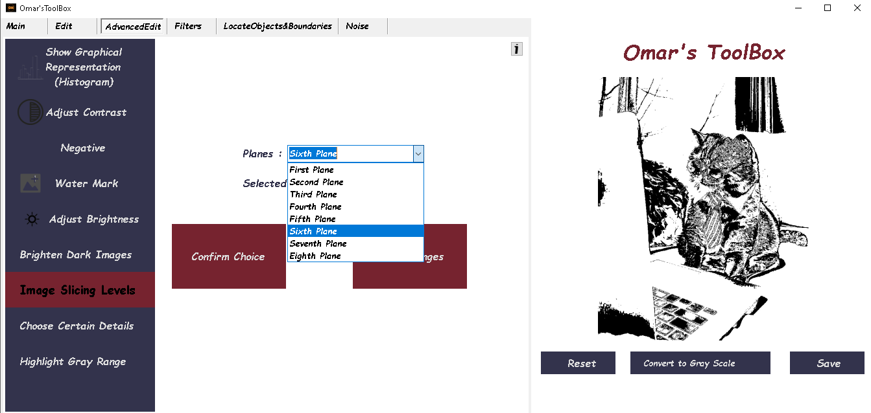 -Converting a gray level image to a binary image.

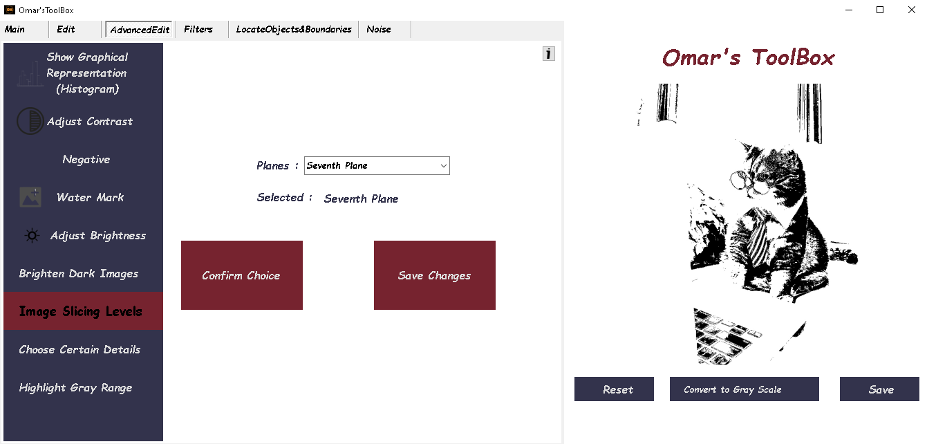

### 8-Choose Certain Details (Thresholding)

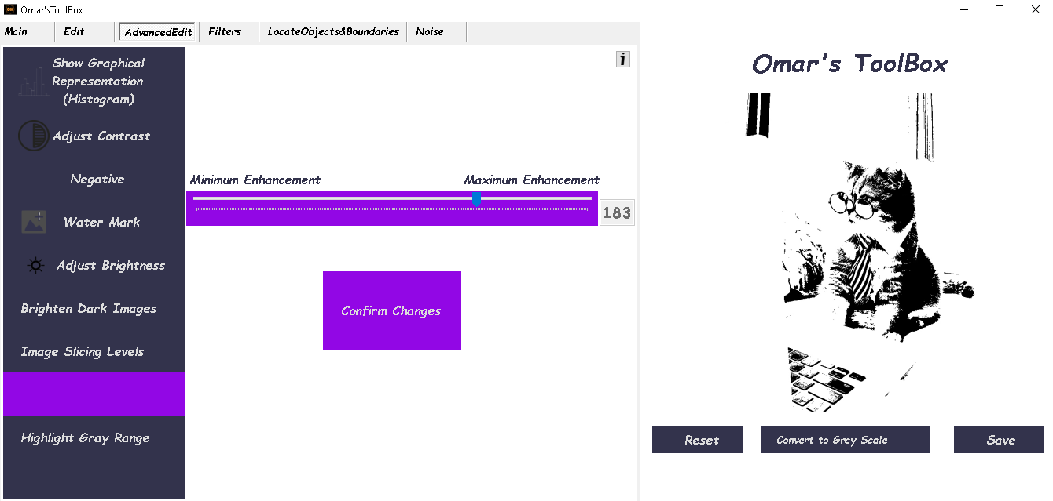 - used to create binary images.

### 9-Highlight Gray range (Gray Level Slicing)

- It’s a way to highlight gray range of interest to a viewer by one of two ways

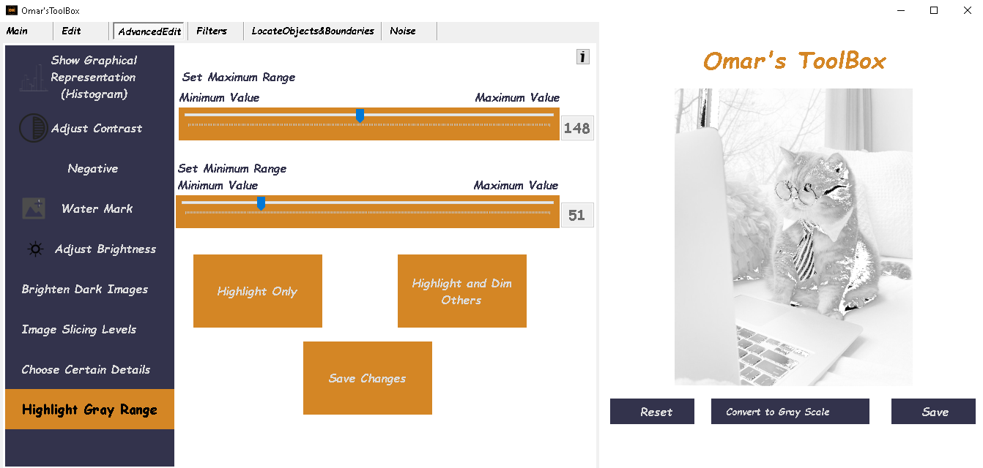Highlight only:

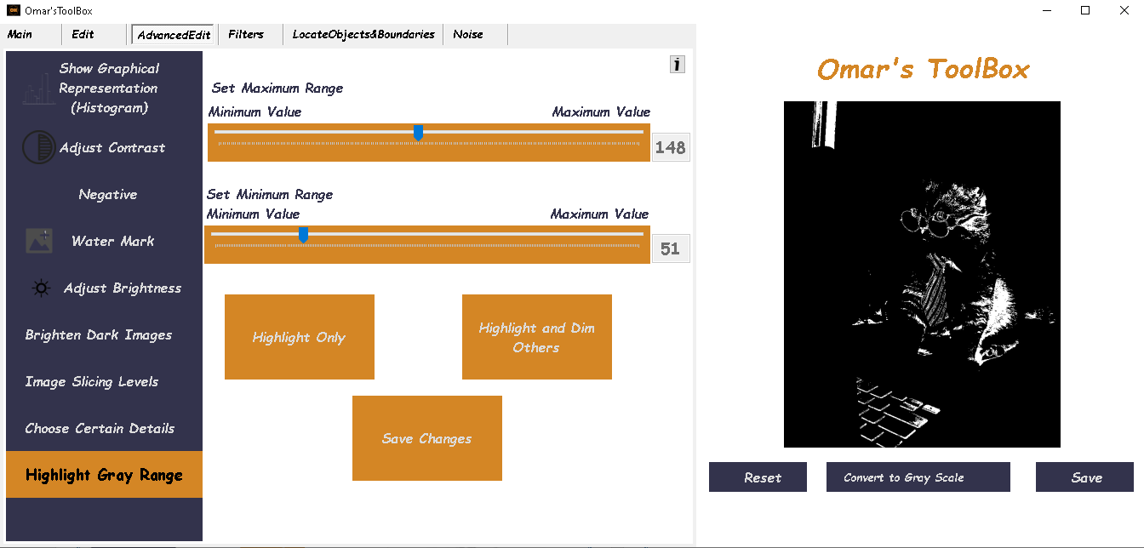Highlight and dim others:

The Fourth Tab is **Filters (**for the Neighborhood Processing operations**)**

## **Filters**

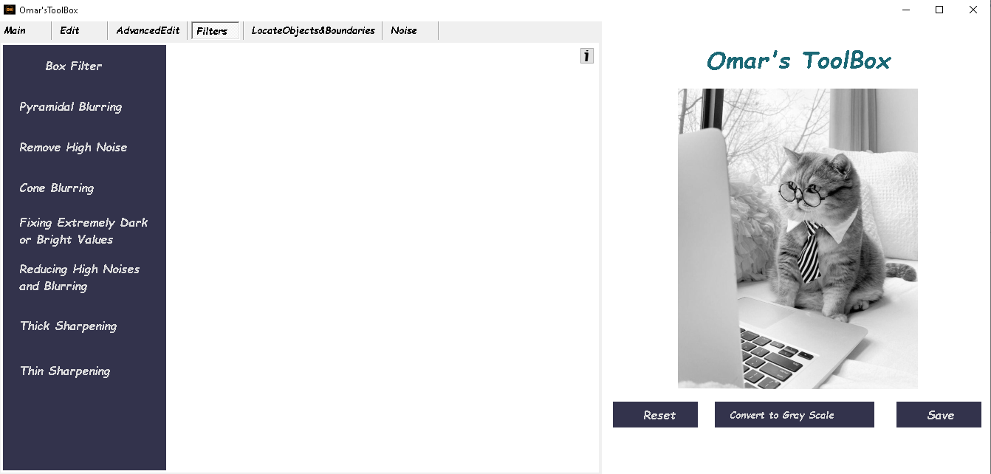

### 1-Box Filter (Traditional Filter)

-Smoothing filter

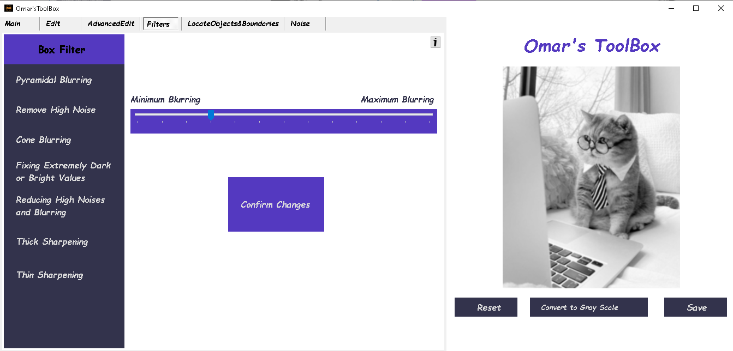The trackbar controls the size of the filter’s Matrix

### 2-Pyramidal Blurring (Pyramidal Filter)

-Smoothing filter

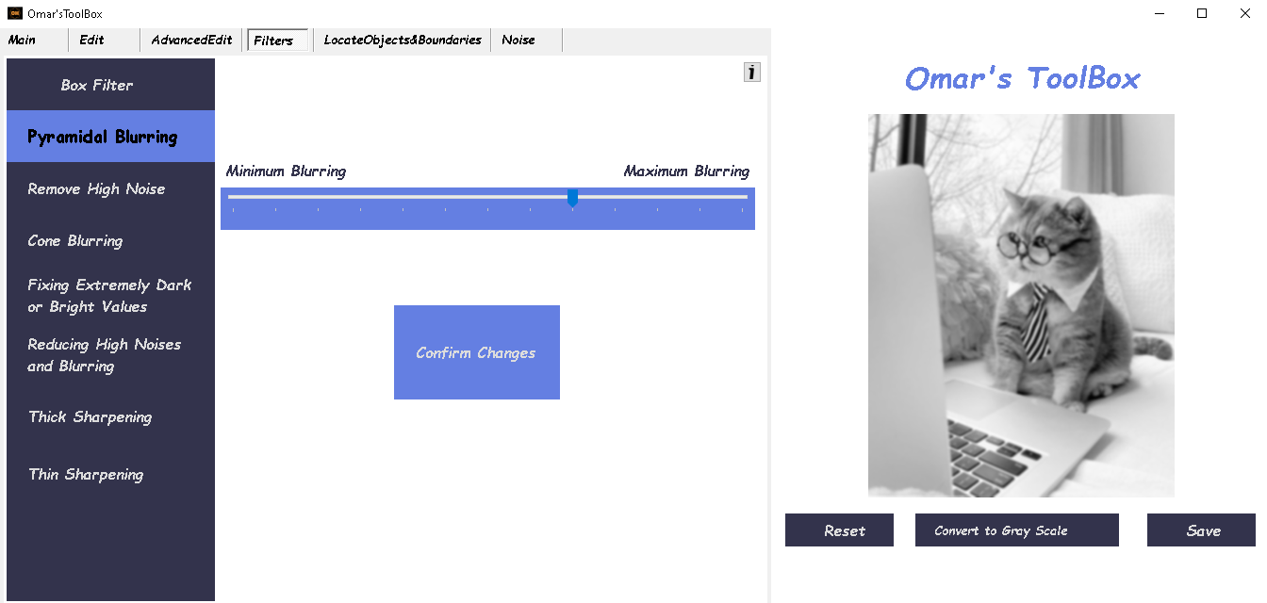The trackbar controls the size of the filter’s Matrix

### 3-Remove High Noise (Circular Filter)

-remove High noise

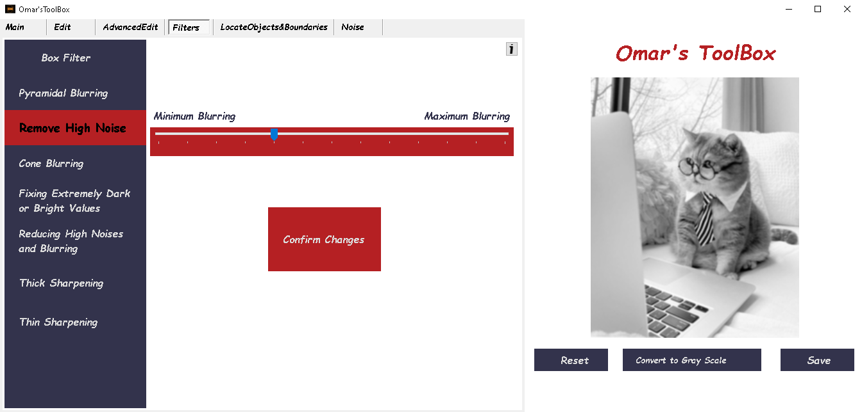The trackbar controls the size of the filter’s Matrix

### 4-Cone Blurring (Cone Filter)

-Smoothing filter

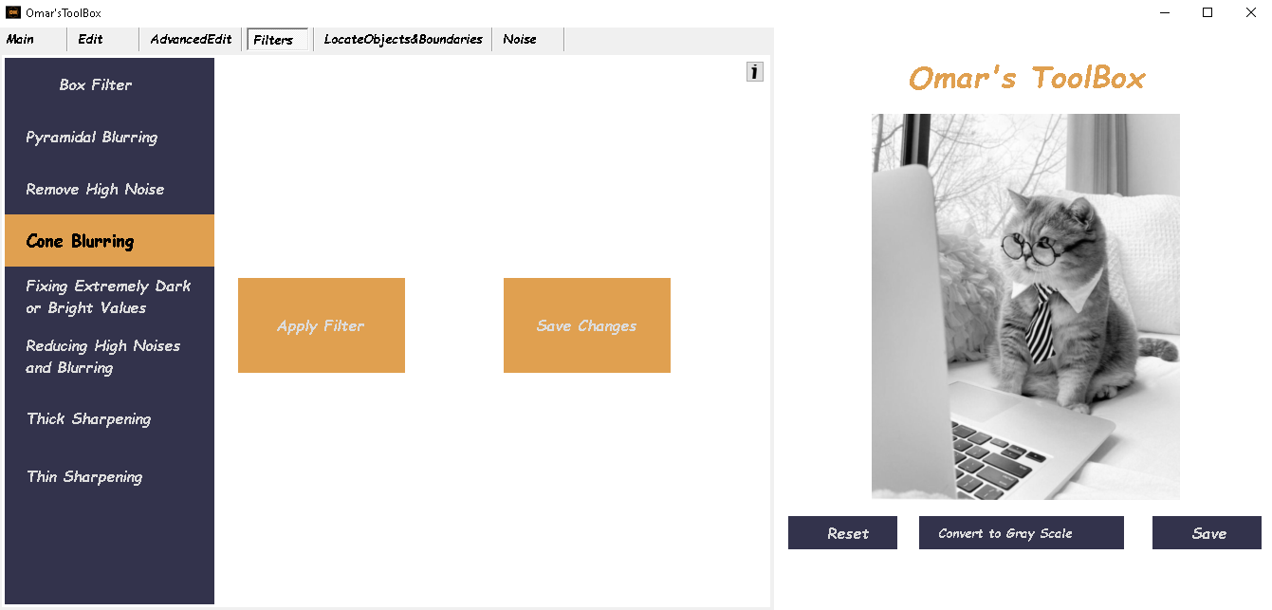The trackbar controls the size of the filter’s Matrix

### 5-Fixing Extremely Dark or Bright Values (Median Filter)

-remove salt and pepper noise

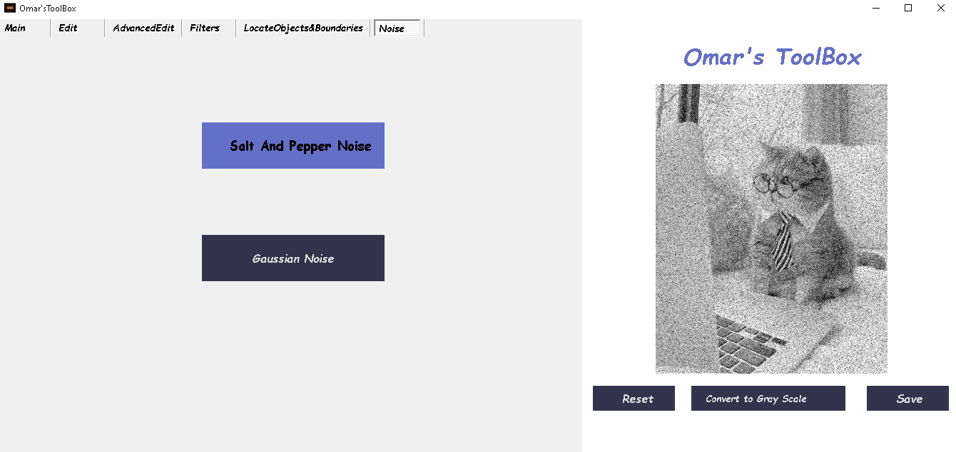The trackbar controls the size of the filter’s Matrix

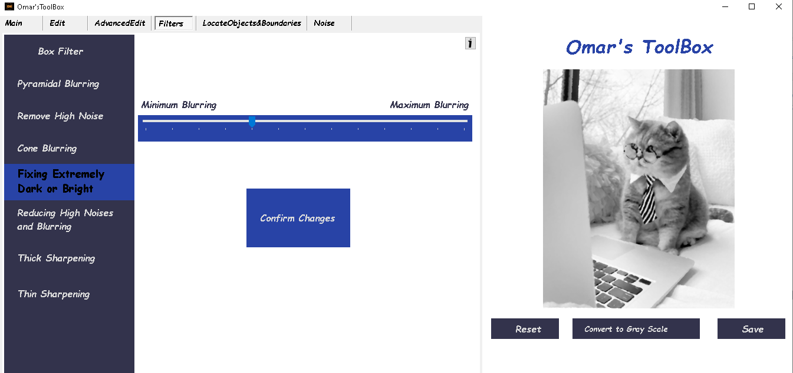

### 6-Reducing high noises and blurring (Gaussian Filter)

-remove High noise

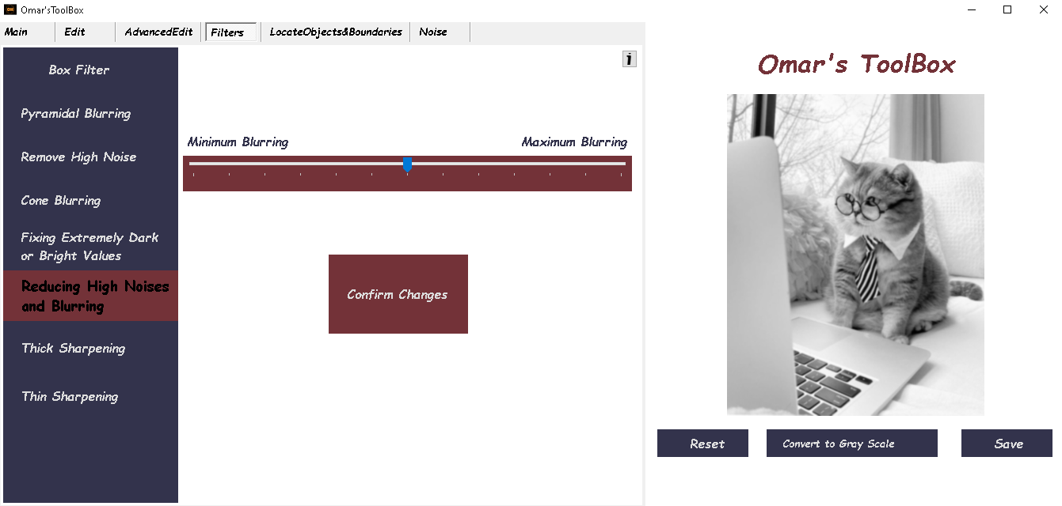The trackbar controls the size of the filter’s Matrix

### 7-Thick Sharpening (Sobel Filter)

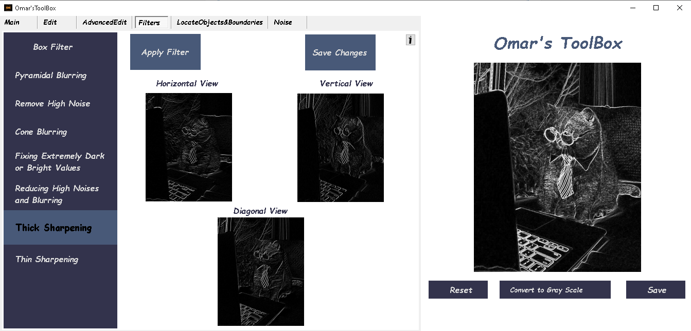First Click Apply filter

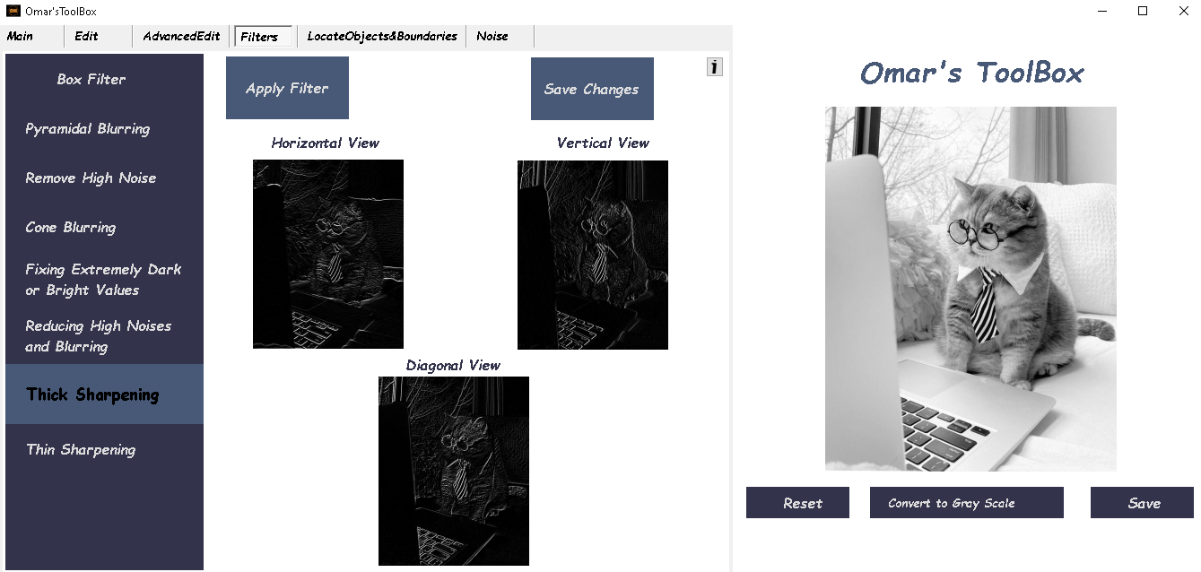Then Click Save changes to sharpen the original image

### 8-Thin Sharpening (Laplacian Filter)

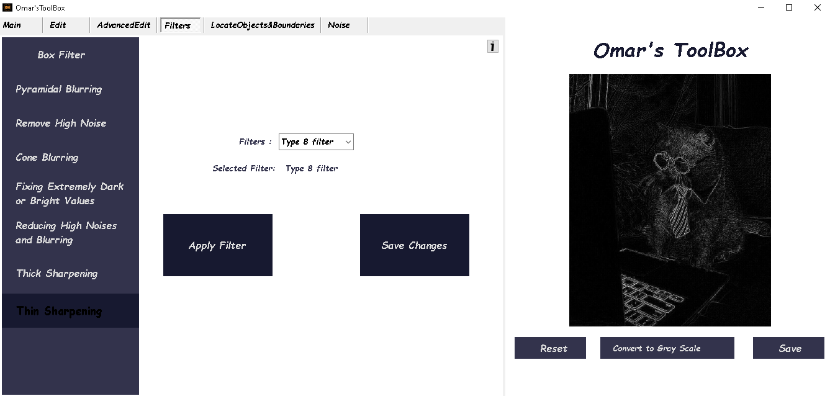First Choose the filter size and Click Apply filter

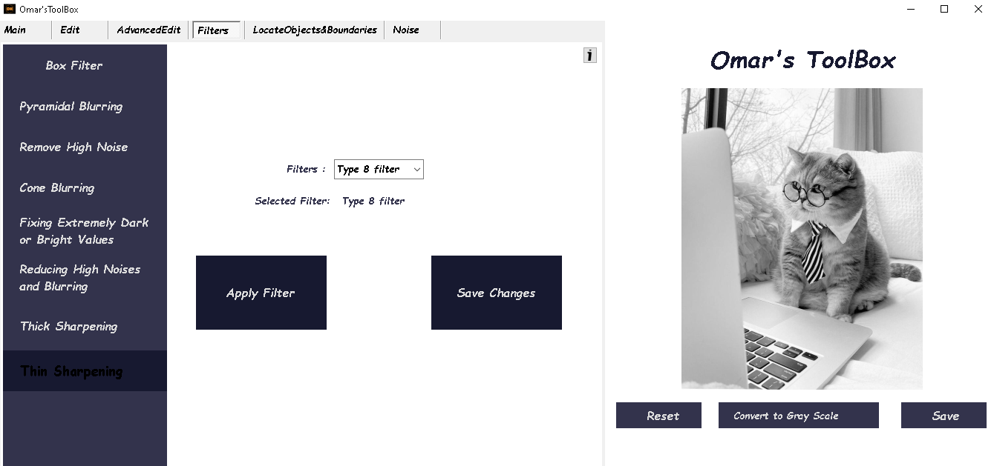Then Click Save changes to sharpen the original image

The Fifth Tab is **Locate objects and boundaries (**for the Segmentation operations**)**

## **Locate Objects and Boundaries**

### 1-Detecting Thin Edges (Laplacian Segmentation)

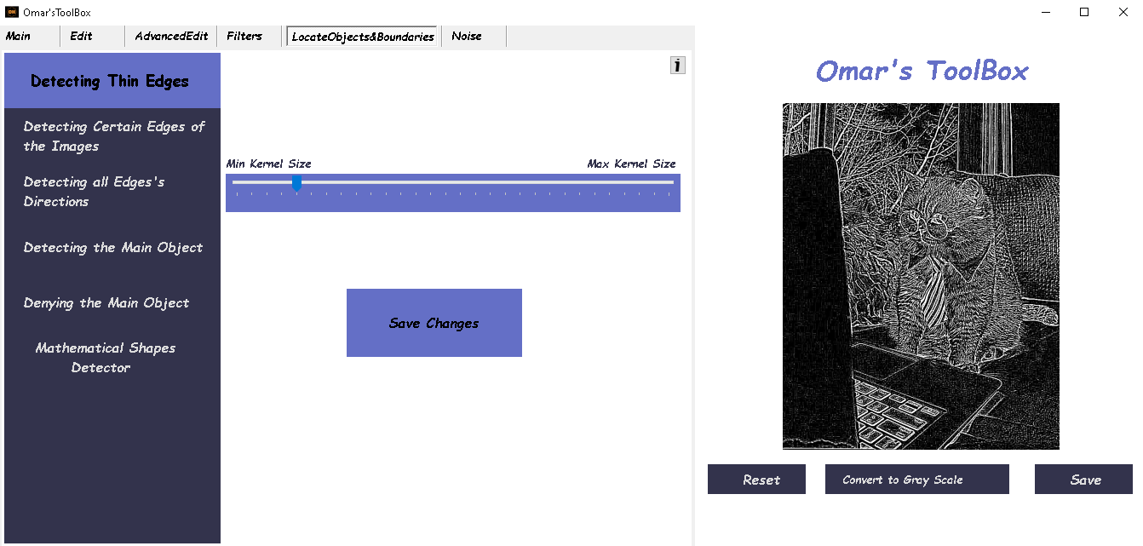Track bar is for matrix size

### 2-Detecting Certain Edges Of The Images (Thresholding Segmentation)

Track bar is for Thresholding value

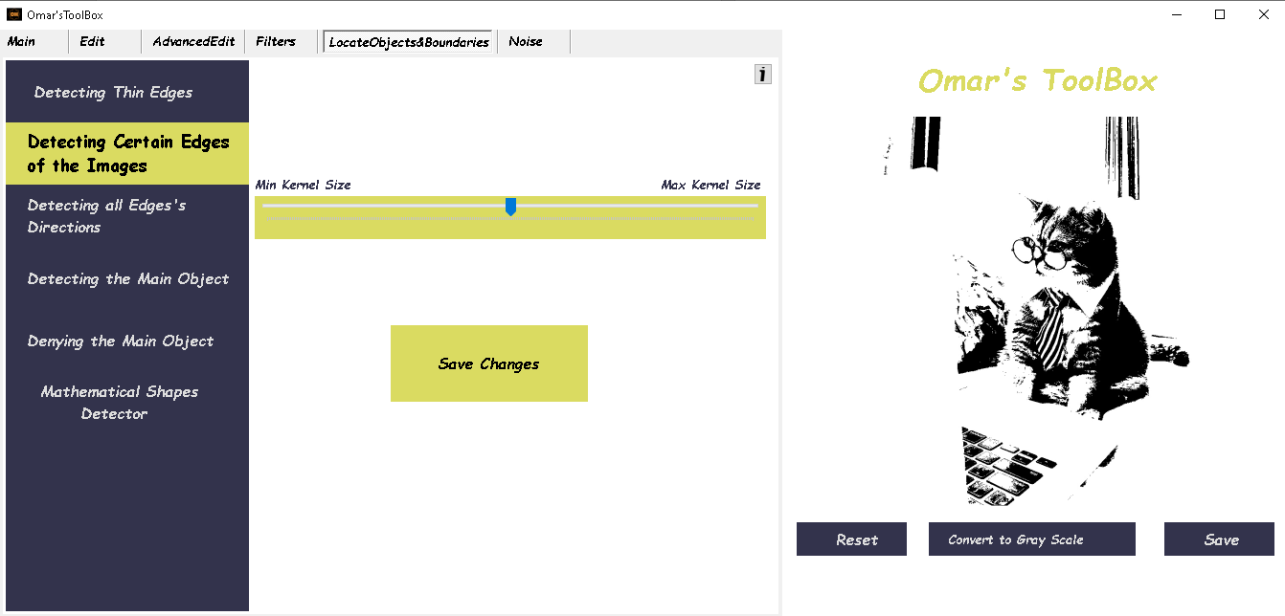

### 3-Detecting all Edge’s Direction (Sobel Segmentation)

### 4-Detecting the main object (DFT Low Pass Filter)

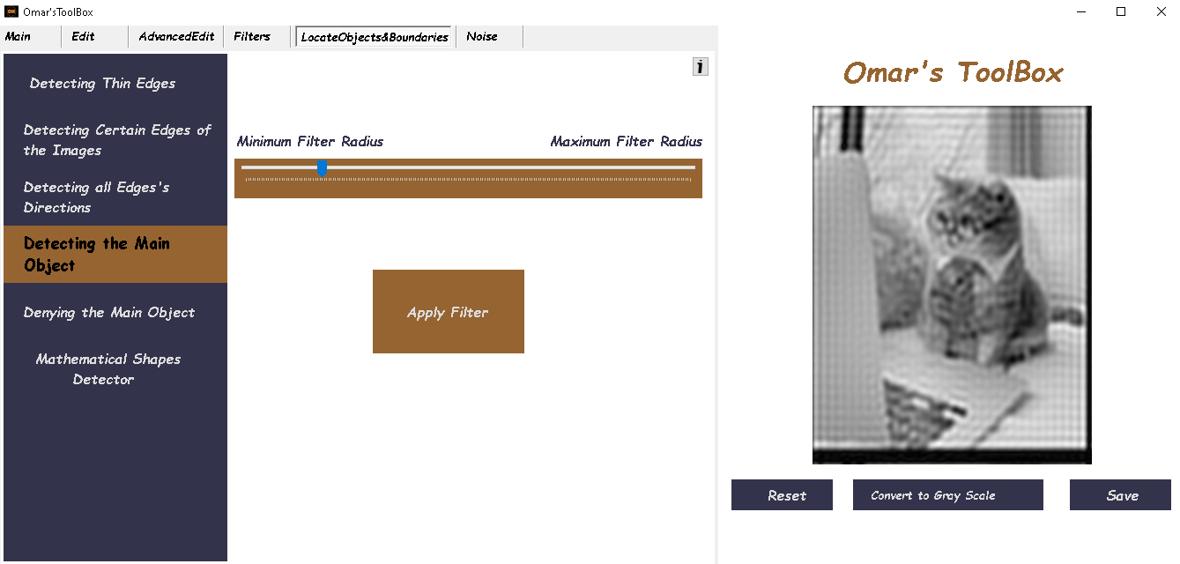Track bar is for the smoothing value

### 4-Denying the main object (DFT High Pass Filter)

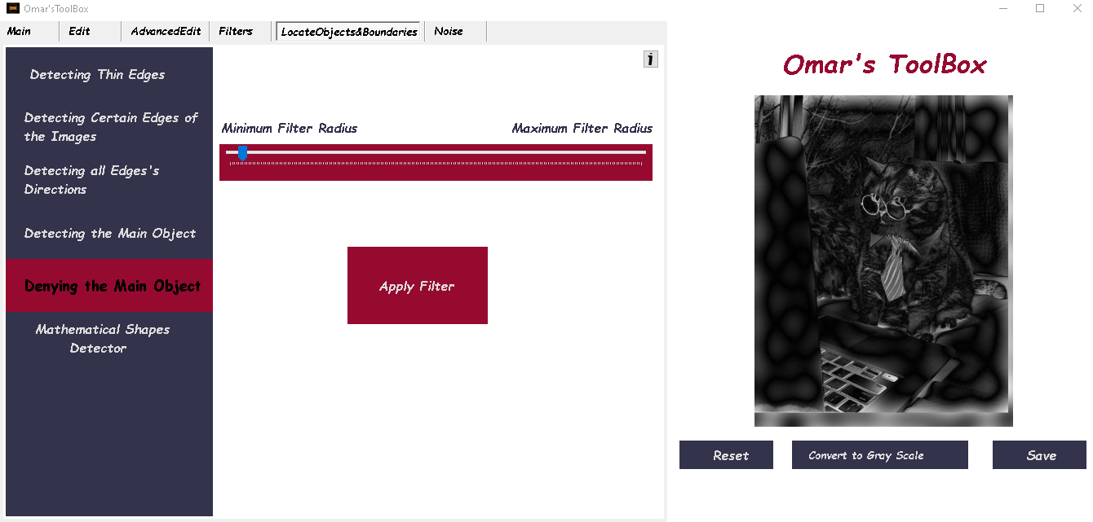Track bar is for the high frequency’s selection

### 5-Mathematical Shapes Detector (Shapes Recognition)

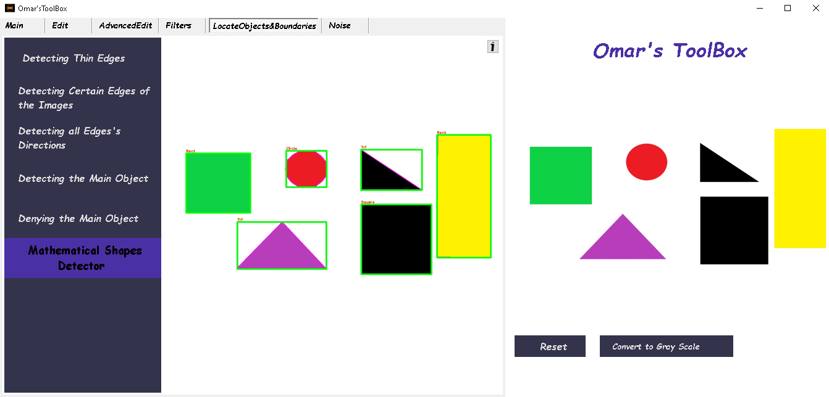 -Recognize the graphical shapes

The sixth Tab is **Noise (**to add noise to the image**)**

## **Noise**

### 1-Salt and pepper Noise

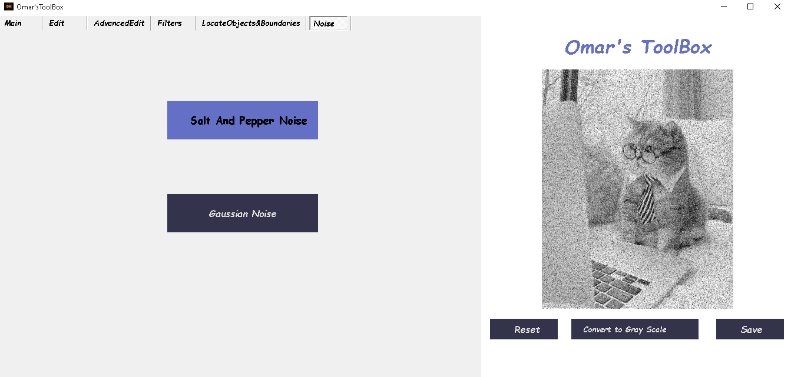 -adds Salt and pepper noise to the image

### 2-Gaussian Noise

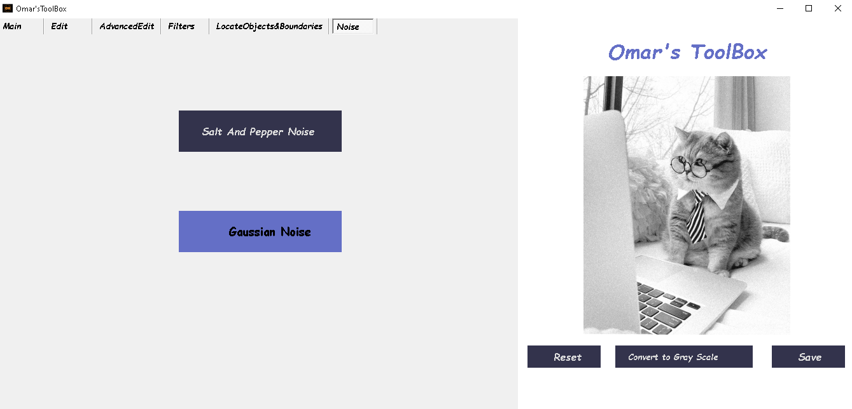 -adds Gaussian Noise to the image

## Themes

### A screenshot of a computer Description automatically generated1-Dark Theme

### A screenshot of a computer Description automatically generated2-Gray Theme

### A screenshot of a computer Description automatically generated3-White Theme